Configuring Cluster with kubeadm
Kubeadm allows use to quickly provision a secure K8s cluster.
Let’s create 2 servers which is having more memory with more CPU as a master and the less memory and the less cpu/ ram as worker. After creating we can directly install the kubeadm on the server since we are doing this from scratch we will install the container runtime as well. To install the container runtime got through this doc Installing kubeadm | Kubernetes.
We have 3 container runtime 1. Containerd 2. CRI-O 3. Docker engine (using cri-dcokerd). Here we are using containerd.
To install containerd go to this link and run the command on both manager and worker.
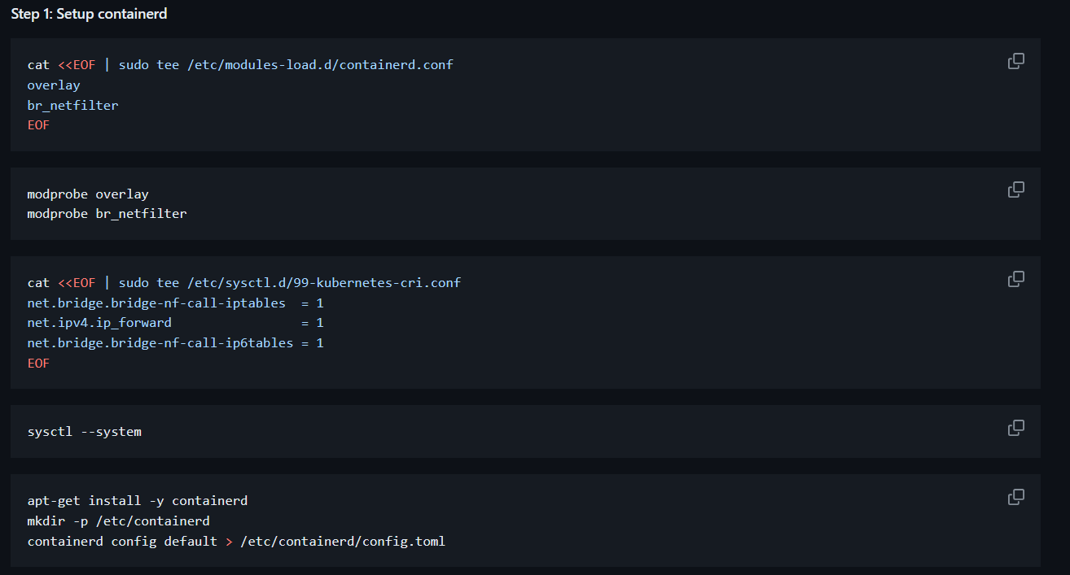
After running the above commands open the “nano /etc/containerd/config.toml” file and look for “systemdCgroup” set it to true. After doing that restart the containerd “systemctl restart contianerd”.
Run the step2 in both Manaager and worker.
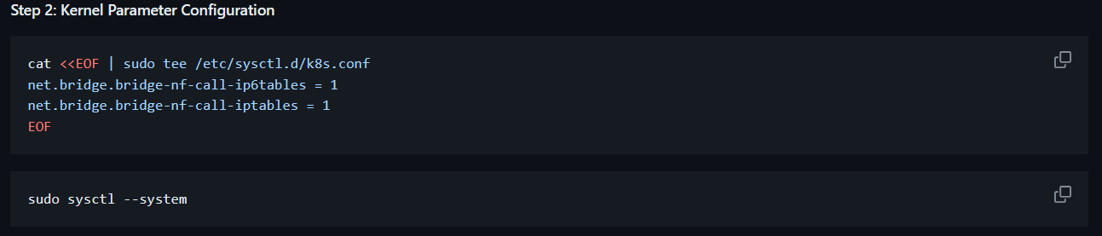
Config the kubeadm:-
The steps you will get from the official K8s doc for kubeadm installation.
Run the below commands on both manager and the worker.
sudo apt-get update
sudo apt-get install -y apt-transport-https ca-certificates curl gpg
curl -fsSL https://pkgs.k8s.io/core:/stable:/v1.29/deb/Release.key | sudo gpg --dearmor -o /etc/apt/keyrings/kubernetes-apt-keyring.gpg
In official doc the command was like this
echo 'deb [signed-by=/etc/apt/keyrings/kubernetes-apt-keyring.gpg] https://pkgs.k8s.io/core:/stable:/v1.29/deb/ /' | sudo tee /etc/apt/sources.list.d/kubernetes.list
it should be
echo 'deb [signed-by=/etc/apt/keyrings/kubernetes-apt-keyring.gpg] https://pkgs.k8s.io/core:/stable:/v1.29/deb/ /' > /etc/apt/sources.list.d/kubernetes.list
and then run
sudo apt-get update
sudo apt-get install -y kubelet kubeadm kubectl
sudo apt-mark hold kubelet kubeadm kubectl

Now run “apt-get update” after running that run “apt-cache madison kubeadm” it will show the all type of kubeadm versions.
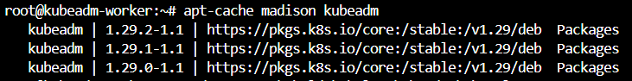
IF we run “sudo apt-mark hold kubelet kubeadm kubectl” it will automatically select the latest version.
we want particular version we need to run “sudo apt-get install -y kubelet=1.29.0-1.1 kubeadm=1.29.0-1.1 kubectl=1.29.0-1.1”.
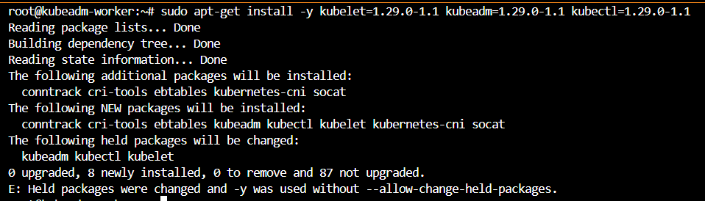
However the version is not showing in the list when we run “apt-cache madison kubeadm” .
“apt-mark hold kubelet kubeadm kubectl”
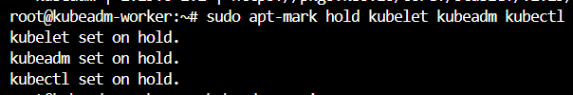
If we run the hold command it won’t change the versions it’s layer of security.
Run below command only on master
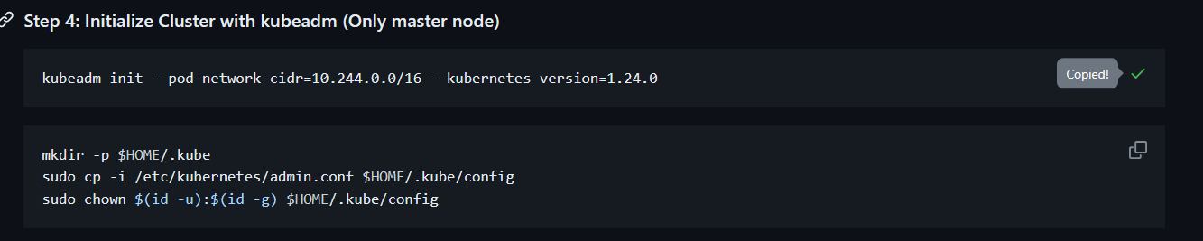
Here our command will be “kubeadm init --pod-network-cidr=10.244.0.0/16 --kubernetes-version=1.24.0”
After running the command we will see this
kubeadm join 134.209.145.78:6443 --token 6y643a.us5hznkcy555htlc \
--discovery-token-ca-cert-hash sha256:1d06d8beff680040734246752da0d81cd409945fbf6b5d6d8e55501fd53dde35
We will use above command later.As of now we will run remaining commands from github doc.
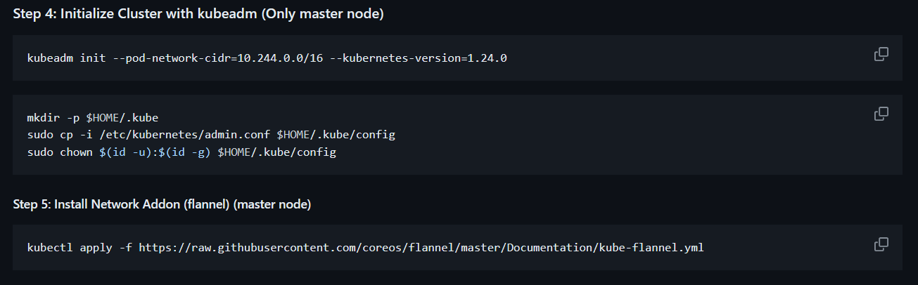
Now we need to connect worker node with the master node before that we will list the worker node from master.
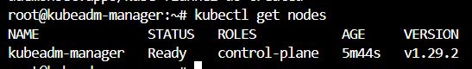
You can see there is no worker node.
Now go to worker node run
kubeadm join 134.209.145.78:6443 --token 6y643a.us5hznkcy555htlc \
--discovery-token-ca-cert-hash sha256:1d06d8beff680040734246752da0d81cd409945fbf6b5d6d8e55501fd53dde35
You can see below output.
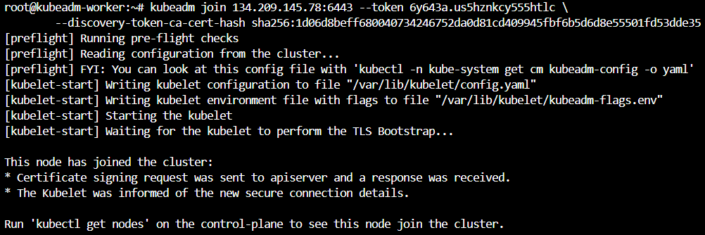
Now If you run ‘kubectl get nodes’ from master node you can see the worker node.
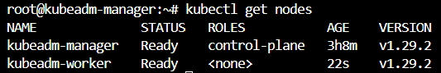
To evaluate this we will create a pod from master node let’s see whether it’s running on worker node or not.
From above SS you can see pod is successfully running on worker node.
Upgrading kubeadm Clusters
High-Level Steps:-
Following are the high-level steps required to perform kubeadm upgrade.
- Find the latest version to upgrade to.
- Unhold the kubeadm binary
- Download the latest kubeadm binary (apt-getinstall)
- Perform the Upgrade Plan
- Choose version to upgrade and run appropriate command
- Upgrade the kubelet and kubectl binaries
- Restart service
Follow the doc for upgrade Upgrading kubeadm clusters | Kubernetes .
*** Hands on for me the upgrade was taking too long more than 5 mins and it’s showing error need to troubleshoot. Task:- Need to create a master with worker node and need to upgrade.
K8s Cluster from Scratch
Goal of the Section:-
We will be configuring K8s Master and K8s Worker node from scratch.
K8s Master has below components:
- Kube-apiserver
- Etcd
- Kube-scheduler
- Kube-controller-manager
- Cloud-controller-manager (we are not doing this in this session)
K8s Worker node has below components:
- Kubelet
- Kube-proxy
Remember the workflow:-
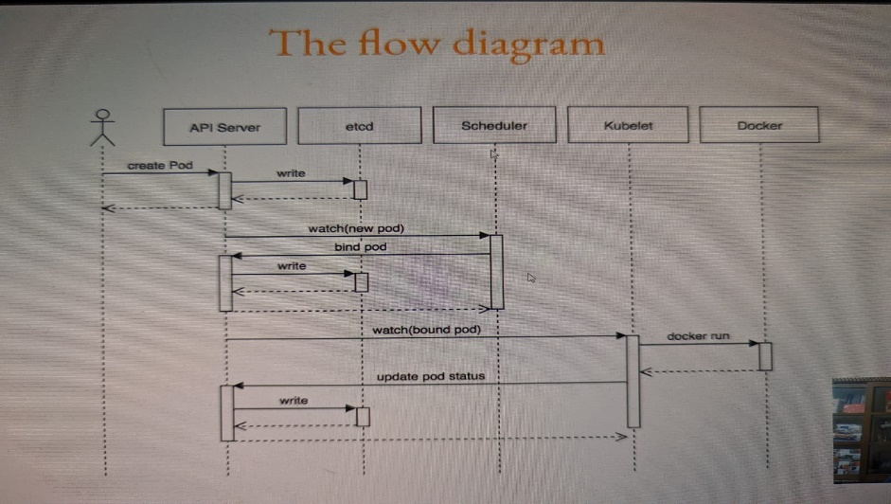
Explantaion of workflow:
Whenever user wants to create a ‘POD’ let’s assume user sending the command in CLI the communication will first go to “API Server”. The “API Server” collects the requirement it will send to “etcd” etcd is the database where it stores the all the data.Once it stores the data the “API Server” will send the information to “Scheduler”. The “Scheduler” will assign on which node the “POD” has to run and it will send that info to “API Server”. The “API Server” again it will send the info to “etcd” to store the data and then the “API Server” will send the info to “kubelet” which is available at the node level the “kubelet” will send the info to the “container run time” in our case it’s “docker”. After creating the pod the “kubelet” will send the info to the “API Server” the “API server” will send the information data to “etcd” to store.
Goal of the section:-
We will be configuring K8s Master with it’s components and K8s Worker node with it’s components from scratch.
Version Constraints:-
New K8s versions are released quite frequently.
Eg: you are working with K8s cluster version 1.24 that means all the components is having the version 1.24. In the future if we get to upgrade it to 1.25 or later version we need to upgrade components also to 1.25. Anyway there will be slighter change in the upgraded version without knowing that change your cluster won’t get up.

K8s Cluster creation Hands on
Create one master node with high specs and worker node with less specs.
Common Patterns-K8s from Scratch
Communications should be Secure: While configuring each components, there are some common set of steps that we will performing at an individual component level. This can include, creating Certificates, Kubeconfig files.
Common Patterns1-Certificates:
We will be generating a set of certificates and keys for each component as part of the cluster for secure communication. This include an each user having each key to access even for components also having keys for each.
Common Patterns 2 -Kubeconfig:
Multiple components needs to interact with the API server.
For this , we will have to create kubeconfig file for individual components.
API Server
Scheduler
Kubeconfig
API-127.0.0.1:6443
Certificate and keys

Common Pattern 3 – Configuration for Components: Each component of a cluster will have a unique set of configuration options that controls the functionality.
API Server
Config options
--allow-privileged
-client-ca-file string
--audit-log-compress

Common Patterns 4 – Systemd File: We will also create a systemd unit configuration file that encodes information about a process controlled and supervised by system. Systemd also can ensure to start the component automatically when system reboots.
Kube-apiserver.service
Systemd
Kube-scheduler.service
Kubelet.service
Provisioning Release Binaries
Before we start configuring the cluster, we have to first download the binaries associated with all the components.
Release Binaries:- K8s Release Binaries are divided into three categories.
- Server
- Node
- Client
Release Binaries | Description
Server | Contains binaries for master server components like API Server, Controller Manager, Scheduler and others
Node | Containers Binaries required by worker nodes. Kubelet, kube-proxy
Client | Binaries required by client, kubectl.

In google need to search for “Kubernetes changelog” there you will get official Kubernetes git repo kubernetes/CHANGELOG/CHANGELOG-1.20.md at master · kubernetes/kubernetes · GitHub . From there you can select which ever changelog version you need and then you can download the packages.
Now we are going download the master component in master node and worker components in worker node. For that we are going to use which exactly the tutor is used that is OS version K8s binary version etc.
We have to follow the exact steps which tutor has provided in the this github link certified-kubernetes-administrator/Domain 6 - Cluster Architecture, Installation & Configuration/k8s-scratch-step-1-download-release-binaries.md at master · zealvora/certified-kubernetes-administrator · GitHub .
*** Need to do for the latest one.
Let’s see what we haven’t follow the tutor instructions and what are all things we need to consider while installing.
- We need select the binary version after selecting that for client,server,node will be having compressed binaries like below.
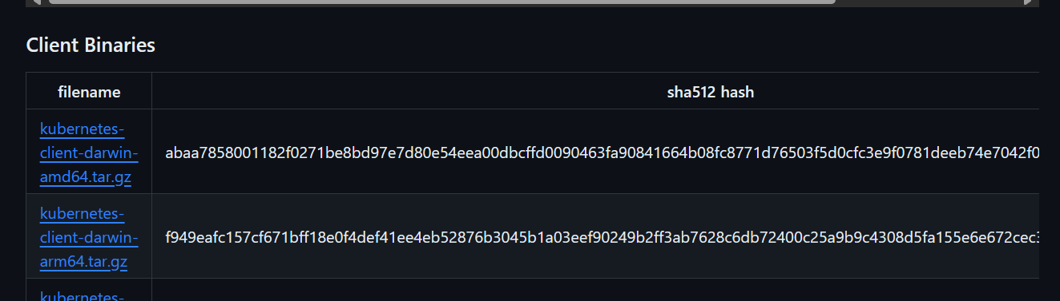
- Now we need to download worker binary in worker node and master binary master node by using get command.
- After downloading it we need to extract the packages.
- Now if you see the master package there won’t be the master component etcd. Etcd itself is the separate tool or service we need to go to their official github to install this.
- The etcd website is Release v3.5.4 · etcd-io/etcd · GitHub . There we need to select the latest version then download and extract it.
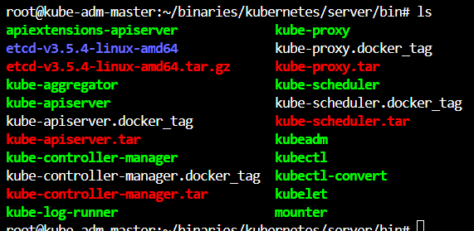
As of now we are going with tutor instructed versions.
Go to master run below commands:
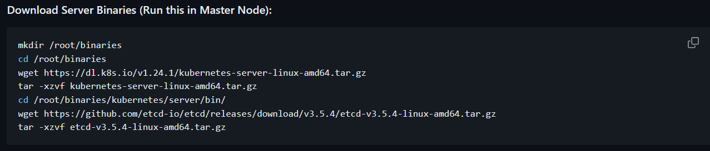
Go to node run below commands:
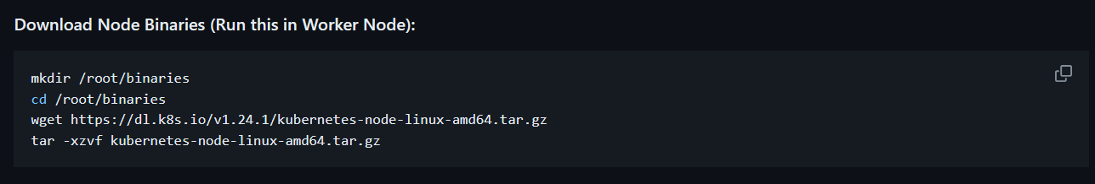
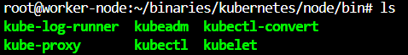
Configuring the Certificate Authority
Communication Should Be Secured:
- There are multiple components which will be communicating with each other.
- When communication is in plain-text, it is prone to lot of attacks.
- Hence it is important to have secure communication between multiple components.
- This can be achieved with the help of certificates.
Certificate Authority:
- Certificate Authority is an entity which issues digital certificates.
- Key part is that both the receiver and the sender trusts the CA.
Eg: If multiple users are accessing the components the CA (certificate authority) will assign the each signed certificate for each user.
Follow the steps given in this link certified-kubernetes-administrator/Domain 6 - Cluster Architecture, Installation & Configuration/k8s-scratch-step-2-configure-ca.md at master · zealvora/certified-kubernetes-administrator · GitHub
Step1: Creating a private key for Certificate Authority:
Step2: Creating Certficate signing request:
Step3: Self-Sign the CSR
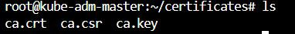
Now we have already certificate got issued, we don’t need “ca.csr” we can delete.
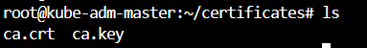
Step4: See contents of certificate, run “openssl x509 -in ca.crt -text -noout”. It will show CN, EXPIRY DATE and PUBLIC KEY content.
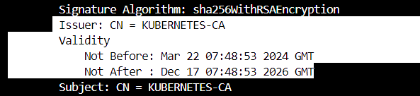
Public key:
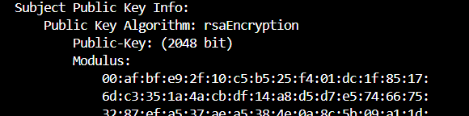
Configuring ETCD
Understanding the etcd: etcd is a distributed reliable key-value store.
etcd reliably stores the configuration data of the K8s cluster, representing the state of the cluster at any given point of time.
- Now we need to generate CSR (certificate signing request) for ETCD.
- We need CSR to CA. The CA will review the ETCD’s CSR.
- Once the review is completed the CA will sign the certificate.
- The final signed certificate we will be using as a part of ETCD component.
The same above process we need to use for remaning components as well.
Hands on:
To do hands on follow the list of commands provided in the mentioned link certified-kubernetes-administrator/Domain 6 - Cluster Architecture, Installation & Configuration/k8s-scratch-step-3-install-etcd.md at master · zealvora/certified-kubernetes-administrator · GitHub
Step1: create a variable of public ip
Step2: Configure the certificates
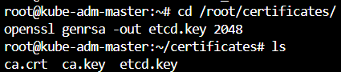
Run below script which collected from github.
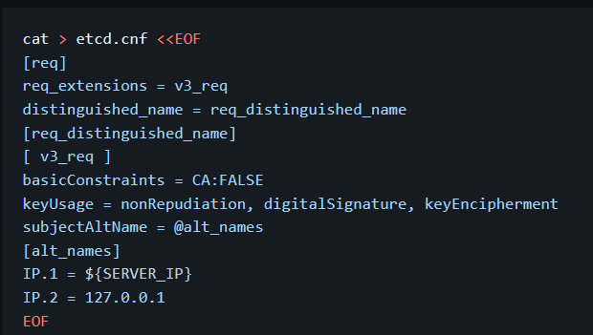
Creating ‘csr’ for ‘etcd’
In the below command we are going to uses CA cert and CA key and we will create a certificate for etcd.
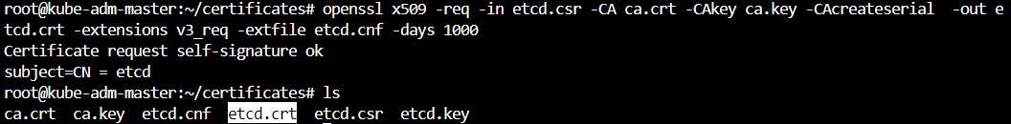
Step 3: Copy the certificates and key to /etc/etcd
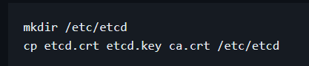
Step 4: Copy the ETCD and ETCDCTL Binaries to the Path
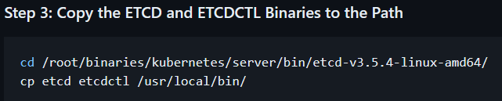
If you run ‘etcd’ you can see the some process. There you can see ‘serving client traffic insecurely’
Now we need to secure it which should be suitable for PROD as well.
Step5 : Configuring the system file
Run below script
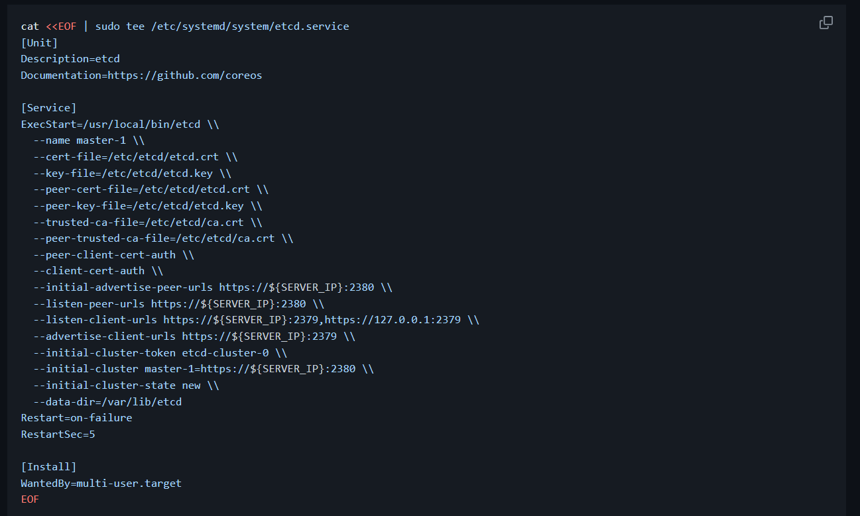
You can see cert-file,key-file,peer-key-file,trusted-ca-file etc… to secure the connection. You can see data-dir where the date will be stored you can see ‘/var/lib/etcd’ that is the path to the data directory.
After you run the above script you can see below output.
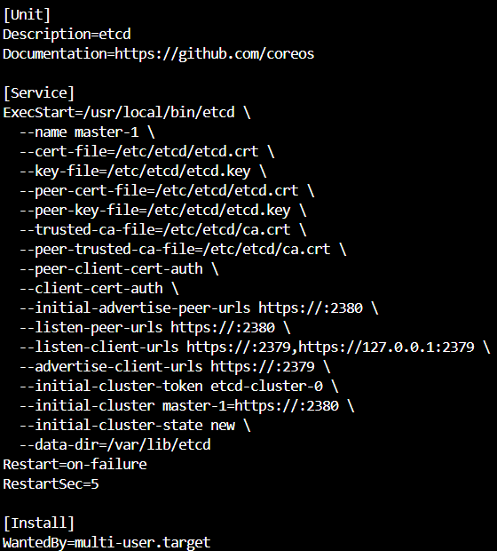
Start Service:
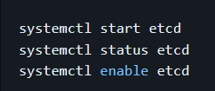
Verification Commands:
If you run “etcdctl --endpoints=https://127.0.0.1:2379 get foo” you will get this.
If you see the highlighted one it should show “faile: x509 …” that means we accessing with unknown authority.
To avoid that we are going to uses certs and key and we will put a message like below.
To retrieve the message we use.
You can see the message “kplabs cka course is awesome”.

Conflicts while doing hands on:
- Issue came up due to IP address while calling as variable.
- Issue came up due to port number. Since unable to kill changed the port number to below parameters
- --listen-client-urls https://${SERVER_IP}:2379,https://127.0.0.1:2379 \\
- --advertise-client-urls https://${SERVER_IP}:2379 \\
- To check any issue analyse the logs inside the /var/log/syslog.
Configuring kibe-api server
Understanding the API Server:
API server acts as a gateway to the K8s cluster.
When you interact with your K8s cluster using the kubectl command-line interface, you are aactually communicating with the master API Server component.
Hands on:
To create this set up follow the github steps certified-kubernetes-administrator/Domain 6 - Cluster Architecture, Installation & Configuration/k8s-scratch-step-4-configure-apiserver.md at master · zealvora/certified-kubernetes-administrator · GitHub
Step1 : Move the kube-apiserver binary to /usr/bin directory
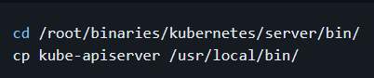
Step2: Generate Configuration File for CSR Creation
Run below script in /root/certificates
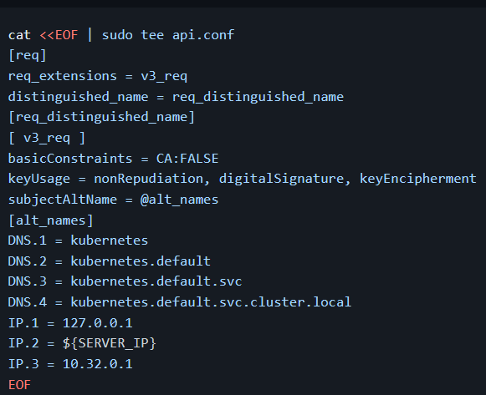
The output will be
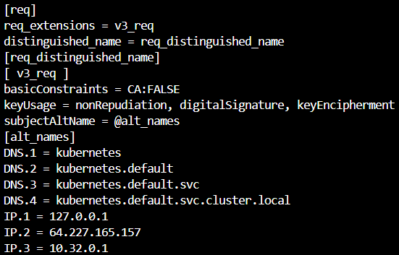
Step3: Generate certificates for API Server
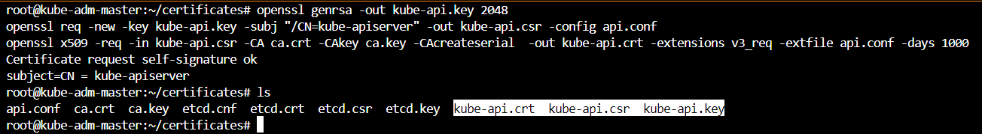
You can see api related files got created in first step we have generated api key and second step we have created api-csr and the third step you will get a signed cert and you will api-cert.
Step4: Generate Certificate for Service Account:
Step5: Copy the certificate files to /var/lib/Kubernetes directory
Step6: Creating Encryption key and configuration
With this we are going to store the keys in encrypted format in ETCD.
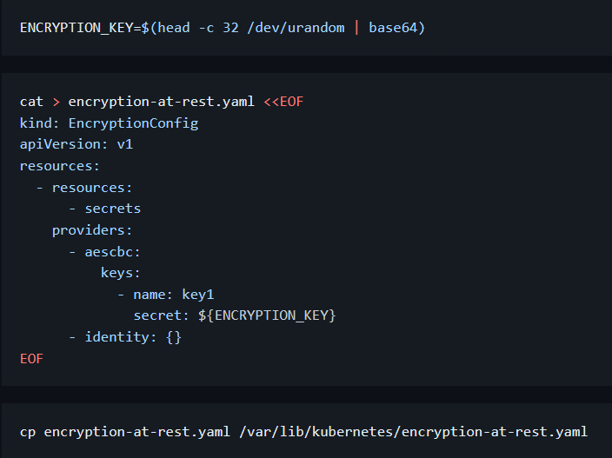
At this point if you run the kube-apiserver.
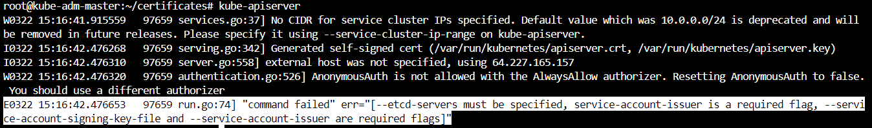
If you see the highlighted one it’s asking missing parameters like service-account-issuer,etcd-servers etc…
For that we need to run below script
cat <<EOF | sudo tee /etc/systemd/system/kube-apiserver.service
[Unit]
Description=Kubernetes API Server
Documentation=https://github.com/kubernetes/kubernetes

[Service]
ExecStart=/usr/local/bin/kube-apiserver \
--advertise-address=${SERVER_IP} \
--allow-privileged=true \
--authorization-mode=Node,RBAC \
--client-ca-file=/var/lib/kubernetes/ca.crt \
--enable-admission-plugins=NamespaceLifecycle,NodeRestriction,LimitRanger,ServiceAccount,DefaultStorageClass,ResourceQuota \
--enable-bootstrap-token-auth=true \
--etcd-cafile=/var/lib/kubernetes/ca.crt \
--etcd-certfile=/var/lib/kubernetes/etcd.crt \
--etcd-keyfile=/var/lib/kubernetes/etcd.key \
--etcd-servers=https://127.0.0.1:2379 \
--kubelet-client-certificate=/var/lib/kubernetes/kube-api.crt \
--kubelet-client-key=/var/lib/kubernetes/kube-api.key \
--service-account-key-file=/var/lib/kubernetes/service-account.crt \
--service-cluster-ip-range=10.32.0.0/24 \
--tls-cert-file=/var/lib/kubernetes/kube-api.crt \
--tls-private-key-file=/var/lib/kubernetes/kube-api.key \
--requestheader-client-ca-file=/var/lib/kubernetes/ca.crt \
--service-node-port-range=30000-32767 \
--audit-log-maxage=30 \
--audit-log-maxbackup=3 \
--audit-log-maxsize=100 \
--audit-log-path=/var/log/kube-api-audit.log \
--bind-address=0.0.0.0 \
--event-ttl=1h \
--service-account-key-file=/var/lib/kubernetes/service-account.crt \
--service-account-signing-key-file=/var/lib/kubernetes/service-account.key \
--service-account-issuer=https://${SERVER_IP}:6443 \
--encryption-provider-config=/var/lib/kubernetes/encryption-at-rest.yaml \
--v=2
Restart=on-failure
RestartSec=5

[Install]
WantedBy=multi-user.target
EOF

If you see it’s having etcd, service account and other details. After running above script to verify use ‘cat’ command to the file /etc/systemd/system/kube-apiserver.service.
Step 7: Start the kube-api server
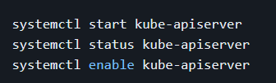
Troubleshooting Failed Cluster Component
Always use “systemctl daemon-reload” if you make any changes in the configuration.
If any component is failing in “systemctl status” it will show auto-restart continuously.
To see the issue run “journalctl -u kube-apiserver” it will display the errors.
If you are unable to see anything after running “journalctl” this will be due to bug in UBUNTU for that run “systemctl restart system-journald”.
Another way is go to /etc/system/system/kube-apiserver.service collect below service command and run directly in the CLI.
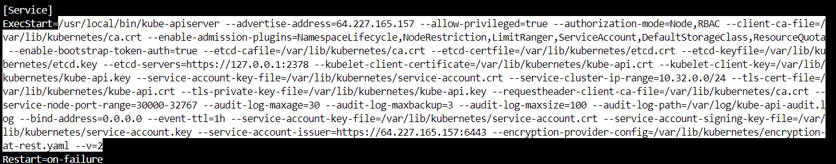
Copy the highlighted on and run in the CLI. It will display issue.
Configuring Controller manager
Understanding the Controller Manager:
Controller manager interacts with API server to move the current state to the desired state.
A controller tracks at least onbe Kubernetes resource type. These objects have a spec field that represent the desired state. The controller(s) for that resource are responsible for making the current state come closer to that desired state.
Node Controllers, Endpoint Controller, Replication Controller, Service Account & Token Controllers.
Hands on:
Step1: Generate certificates:
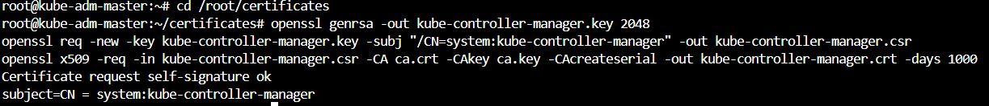
Step2: Generating KubeConfig

Run below commands
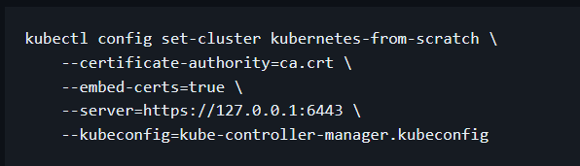
Output will be
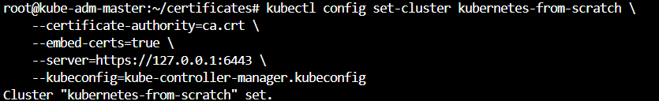
If you below SS the highlighted one are certificate and along with api server ip.
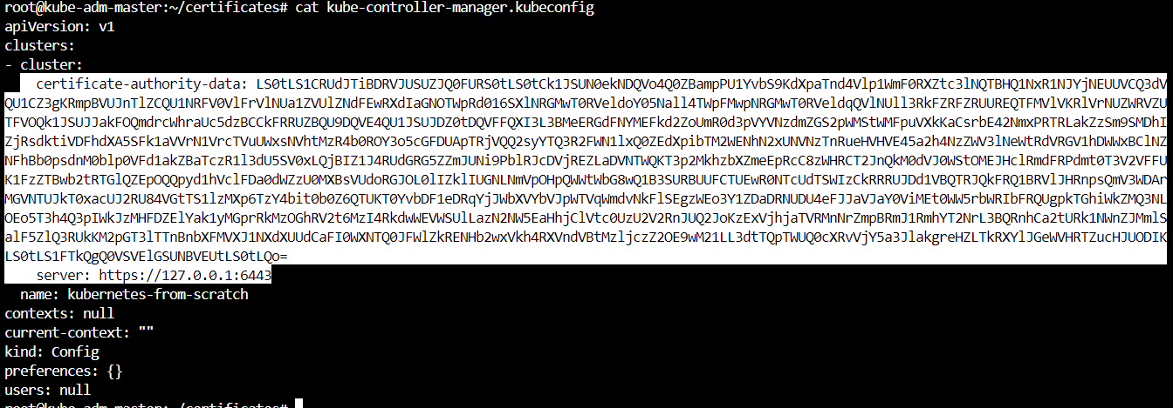
Run
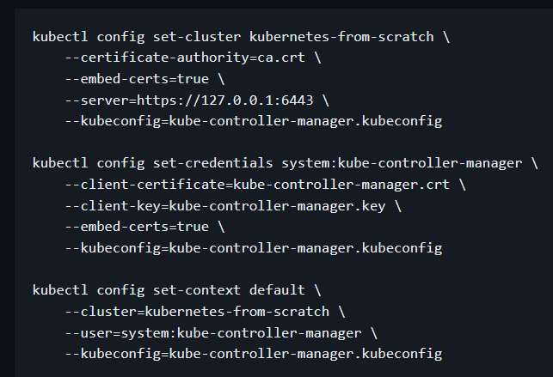
Now if you run again the “cat kube-controller-manager.kubeconfig” you can see the “client-certificate-data” and “client-key-date”.
Run
Step 3: Copying the files to the kuberenets directory
Step4: Configuring SystemD service file
Run
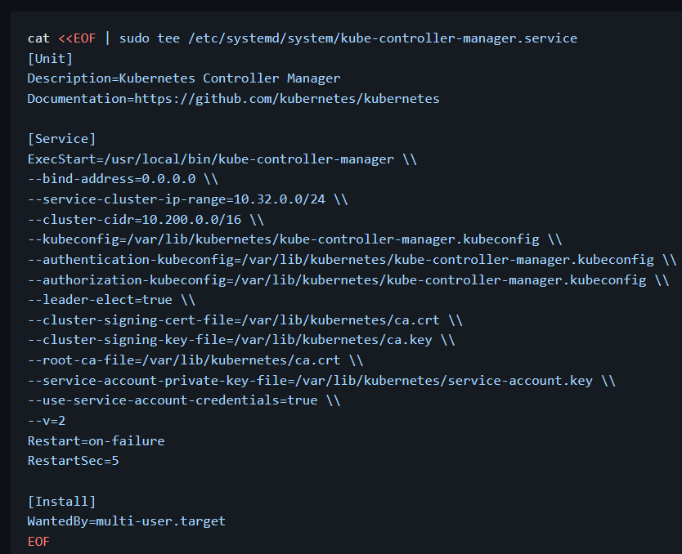
Start controller manager:
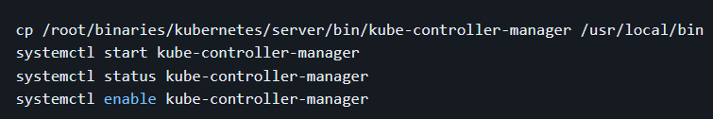

Configuring Scheduler
Understanding the Scheduler:
A scheduler watches for newly created PODS that have no node assigned.
For every POD that the scheduler discovers, the scheduler becomes responsible for finding the best Node for that POD to run on.
Factors for Scheduling:
There are several factors which are taken into consideration before a pod is scheduled to a node. Some of these includes:
- Resource Requirements
- Hardware/Software policy constraints
- Affinity & Anti-Affinity
- Data Locality
Hands on: Use this link for creation certified-kubernetes-administrator/Domain 6 - Cluster Architecture, Installation & Configuration/k8s-scratch-step-6-configure-scheduler.md at master · zealvora/certified-kubernetes-administrator · GitHub
Step1: Generate Certificates
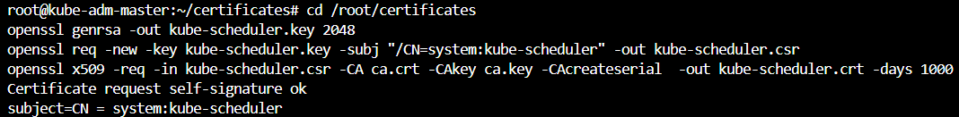
Step2: Generate Kubeconfig file
Run
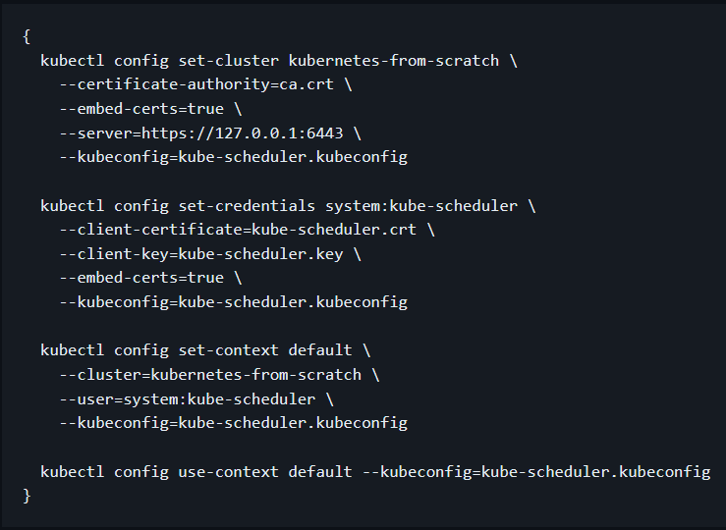
Step3 : Copy the scheduler kubeconfig
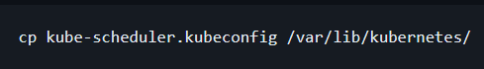
Step4: Configuring system service
Run
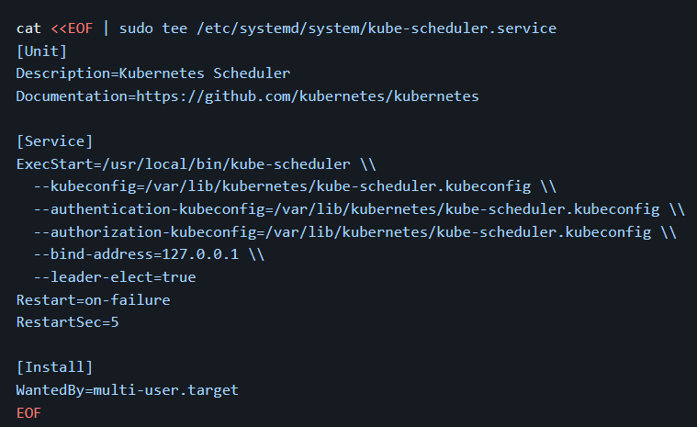
Step5: verification
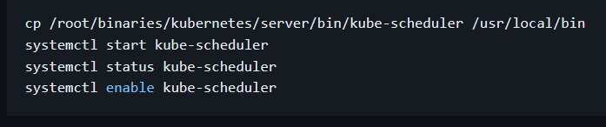
Validating Cluster Components status
We are going to validate the ETCD, API Server, Controller Manager and Scheduler components.
The ‘kubectl’ command which is used to communicate with api server where authentication will be needed for that first we will be having the kubeconfig file for the user that can be connected to the K8s master and create the objects on top of it.
Hands on:
Step1: Generating Certificates for Administrator User
Run
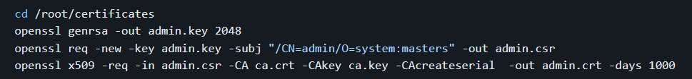
Step2: Create kubeConfig file
Run
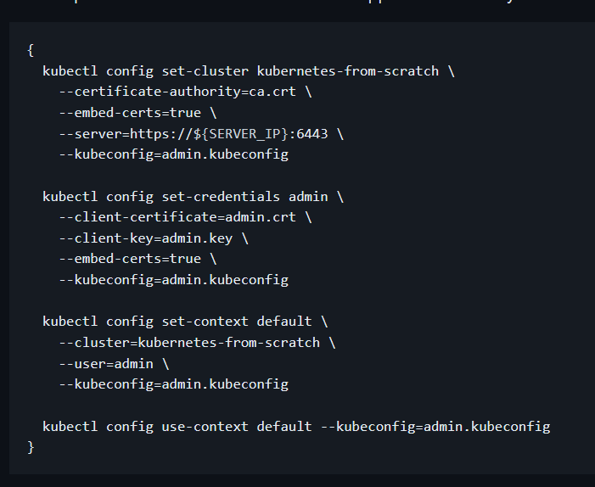
Step3: Verify Cluster Status
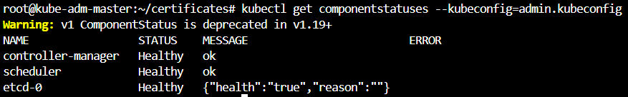
If you run any command with kubectl you need to specify the “admin.kubeconfig” like above to avoid that copy the kubeconfig file to central folder.
cp /root/certificates/admin.kubeconfig ~/.kube/config
Now If you run directly without that it will show.
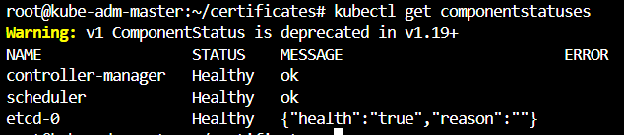
Step4: Verify Kubernetes Objects creation
Now we are going to create the objects to verify our cluster is working fine or not. For that we are going to create a namespace.
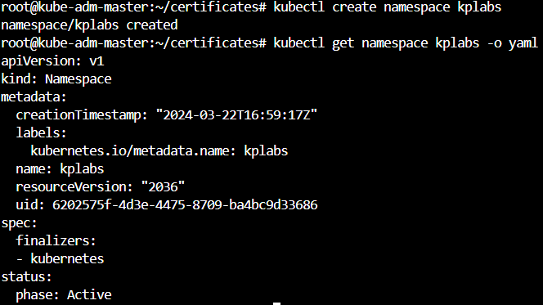
Let’s create the ‘secret’ as well.
You can see we have created a ‘secret’ with the name of ‘prod-secret’ successfully.
Worker Node Configuration
Two important components for Worker node are kubelet and kube-proxy.
Hands on:
One of the pre requisite to for worker node component creation is container runtime. For all the hands on steps us this github link for config certified-kubernetes-administrator/Domain 6 - Cluster Architecture, Installation & Configuration/k8s-scratch-step-8-configure-worker-node.md at master · zealvora/certified-kubernetes-administrator · GitHub .
Run
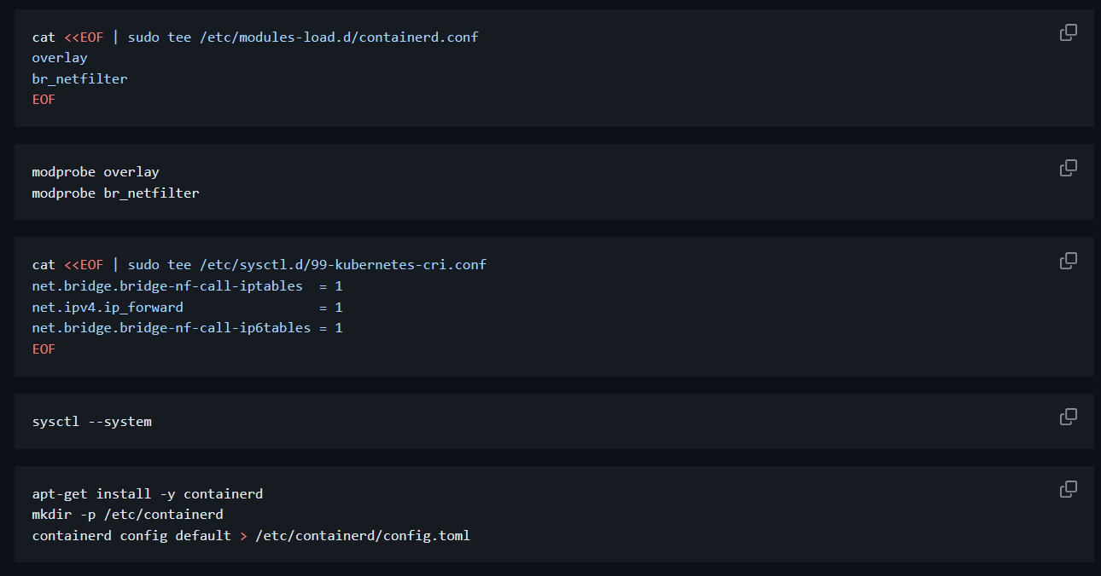
Now edit the file and set the ‘SystemdCgroup=true’. See below SS for more info and run remaining commands as well
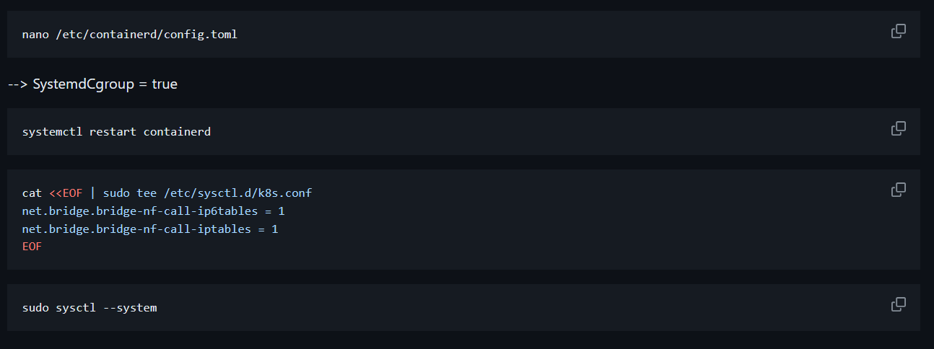
Pre-Requisite-2: (WORKER NODE)
Run
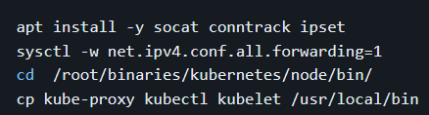
Step1: Generate kubelet certificate for worker node in Master node.
Run
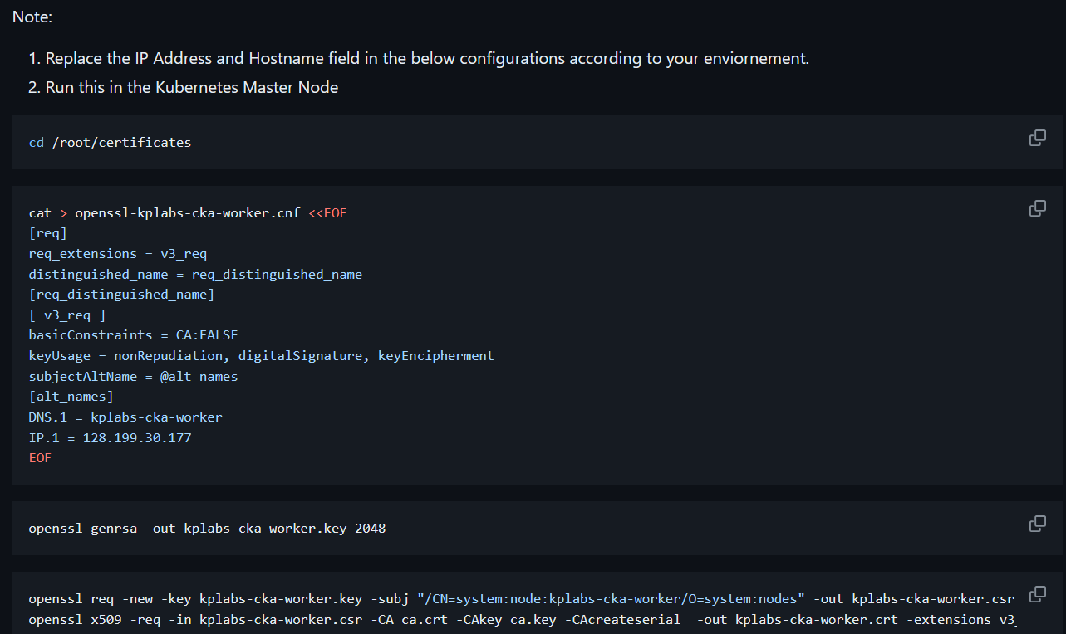
Output
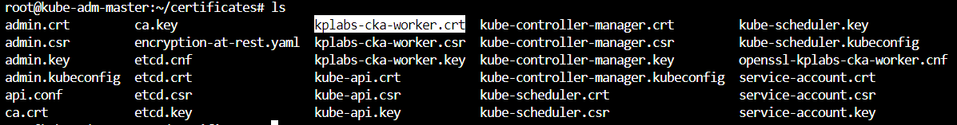
Step2: Generate kube-proxy certificate on Master node
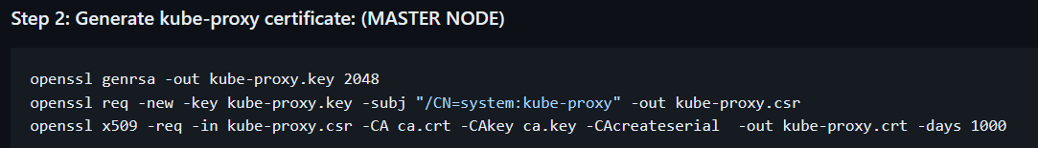
Step3: Copy certificates to worker node.
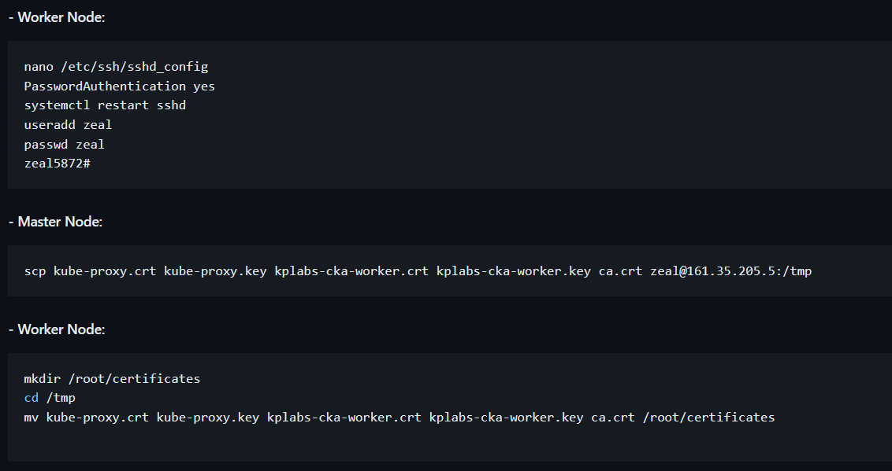
You can see the output
Step4: Move Certificates to Specific location on worker node.
Run
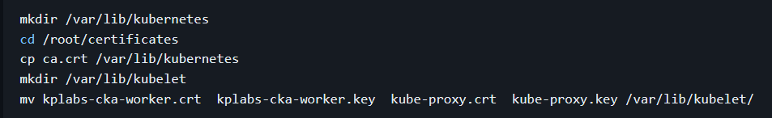
Step5: Generate Kubelet Configuration YAML File on worker node
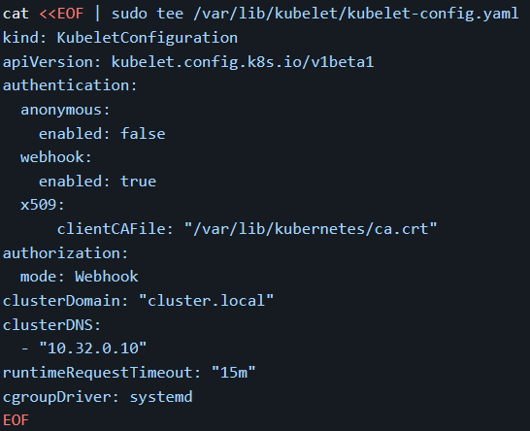
Step6: Generate Systemd service file for kubelet on WORKER NODE
Run
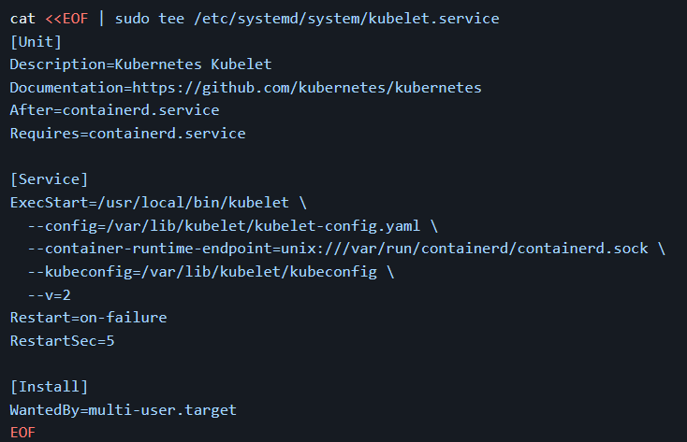
Step7: Generate the kubeconfig file for Kubelet on WORKER NODE
Now we need set up the variable for Master node IP address
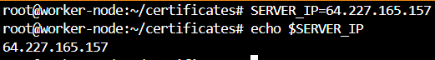
And run
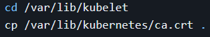
Run
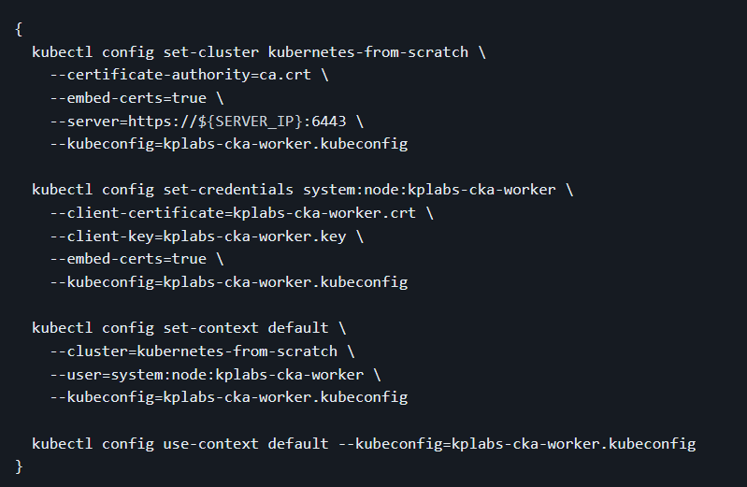
Verification run ‘cat kubeconfig’ there you can see the master node at ‘server’
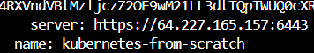
Part-2 Kube-Proxy:
Run
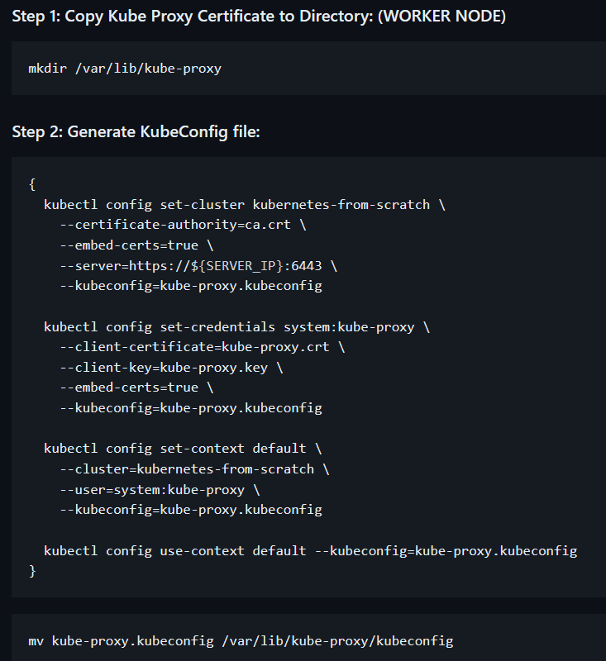
Run
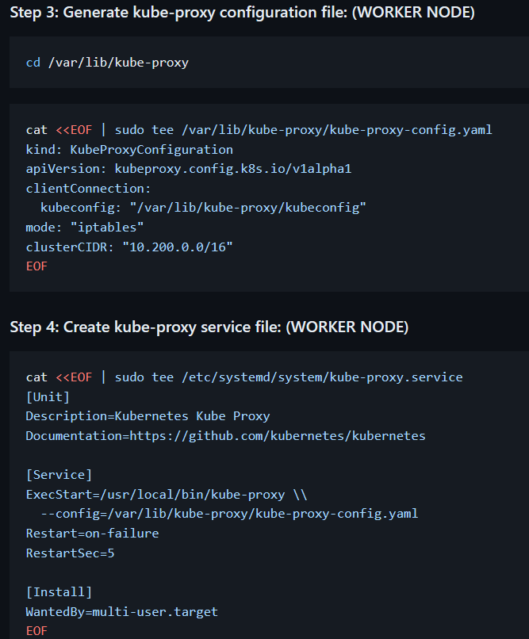
Step5: Start worker node
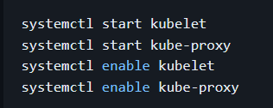
Step6: Go to master node and run “kubectl get nodes”
If we run above command it should show the list of nodes But for me it’s not showing.
***** Due to above issue left this whole topic in the middle and moving to the next topic ******

